Heaven’s Light is our Guide
Rajshahi University of Engineering & Technology
Department of Computer Science & Engineering

Lab Report

Course Code : CSE 2202
Course Name : Algorithm Analysis and Design Sessional
Sessional No : 11
Sessional Topic : Floyd-Warshall, Bellman-Ford

Submitted By:  Name : Md. Alvi Araf  Roll : 2203152  Series : 2022  Section : C | Submitted To:  Md. Mazharul Islam  Lecturer  Department of CSE  RUET

Date of Experiment : 20.10.2025 Date of Submission : 27.10.2025
Sessional No: 11

Problem 1: Floyd-Warshall Algorithm
Logical Solution:
In the Floyd-Warshall Algorithm, we take the graph as an adjacency matrix. Then we select each vertex as an intermediate node to compare if the path from a vertex to another vertex through the intermediate node is shorter than to just directly going from it. If yes, then we update that value in the matrix. In this way, we check all the vertices of the graph and select all the vertices as the intermediate node and check. After all selecting all the vertices as the intermediate node and comparing all the vertices’ distances, we will end up with an adjacency matrix which will contain the shortest paths.
Source Code:
#include <bits/stdc++.h>
using namespace std;

void Floyd_Warshall(vector<vector<int>> graph) {
for (int k = 0; k < graph.size(); k++) {
for (int i = 0; i < graph.size(); i++) {
for (int j = 0; j < graph.size(); j++) {
if (graph[i][j] > (graph[i][k] + graph[k][j])) {
graph[i][j] = (graph[i][k] + graph[k][j]);
}
graph[i][j] = min(graph[i][j], graph[i][k] + graph[k][j]);
}
}
}

for (int i = 0; i < graph.size(); i++) {
for (int j = 0; j < graph.size(); j++) {
cout << graph[i][j] << " ";
}
cout << endl;
}
}

int main() {
int n = 4;
vector<vector<int>> graph(n, vector<int> (n));
graph = {
{0,3,10000,7},
{8,0,2,10000},
{5,10000,0,1},
{2,10000,10000,0},
};

Floyd_Warshall(graph);
}
Input - Output:
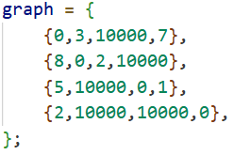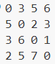
Discussion:
Floyd-Warshall is an algorithm for finding shortest paths in a directed weighted graph with positive or negative edge weights (but with no negative cycles). As there are a total of 3 nested loops, the time complexity of the algorithm is O(V^3) = O(N^3).

Problem 2: Bellman-Ford Algorithm
Logical Solution:
In the Bellman-Ford Algorithm, the distance from the source node is calculated based on the edges. We check if the sum of the distance of the starting vertex of the selected edge and the weight of the edge is less than the distance of the end vertex of the edge. If yes, we update it with the sum. This way, we do for all edges. And the whole process is repeated v-1 times. After this, the final distances of the vertices will be the minimum distances from the source vertex.
Source Code:
#include <bits/stdc++.h>
using namespace std;

int v = 4;
int e = 5;

void Bellman_Ford(vector<pair<int,int>> edge, vector<int> weight) {
vector<int> d(v, 10000);
d[0] = 0;

for (int i = 0; i < v; i++) {
for (int j = 0; j < edge.size(); j++) {
int v1 = edge[j].first;
int v2 = edge[j].second;

if (d[v1] + weight[j] < d[v2]) {
d[v2] = d[v1] + weight[j];
}
}
}

for (int i = 0; i < d.size(); i++) {
cout << i << " " << d[i] << endl;
}
}

int main() {
vector<pair<int,int>> edge(e);
vector<int> weight(e);
edge = {
{0,1},
{0,3},
{1,0},
{1,2},
{2,0},
{2,3},
{3,0}
};
weight = {3,7,8,2,5,1,2};

Bellman_Ford(edge, weight);
}
Input - Output:
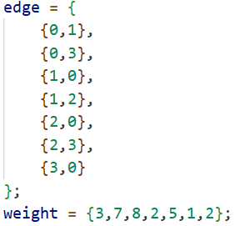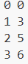
Discussion:
The Bellman–Ford algorithm is an algorithm that computes shortest paths from a single source vertex to all of the other vertices in a weighted graph. It is slower than Dijkstra's algorithm for the same problem, but more versatile, as it is capable of handling graphs in which some of the edge weights are negative numbers. The time complexity of this algorithm is O(VE).

